Objectives
- To understand and implement the Storage concept in GPSS.
- To simulate multi-server systems (e.g., 3 inspectors or 2 fuel nozzles).
- To model real-world systems like inspection units and fuel stations.
- To observe how limited resources (e.g., servers/nozzles) affect flow and service.

Q.no.1. A machine tool in a manufacturing shop is turning out parts at the rate of every 5 minutes. When they are finished, the parts are sent to an inspector, who takes 4 ± 3 minutes to examine each one and rejects 15% of the parts. Write a GPSS program to simulate using the concept of storage.
(Here, storage has 3 servers and timing parameters are changed.)
Source Code
GENERATE 5,,,1000
ENTER INSPECTOR,1
ADVANCE 4,3
LEAVE INSPECTOR,1
TRANSFER .15, REJECT
TERMINATE 1
REJECT TERMINATE 1
INSPECTOR STORAGE 3

Output
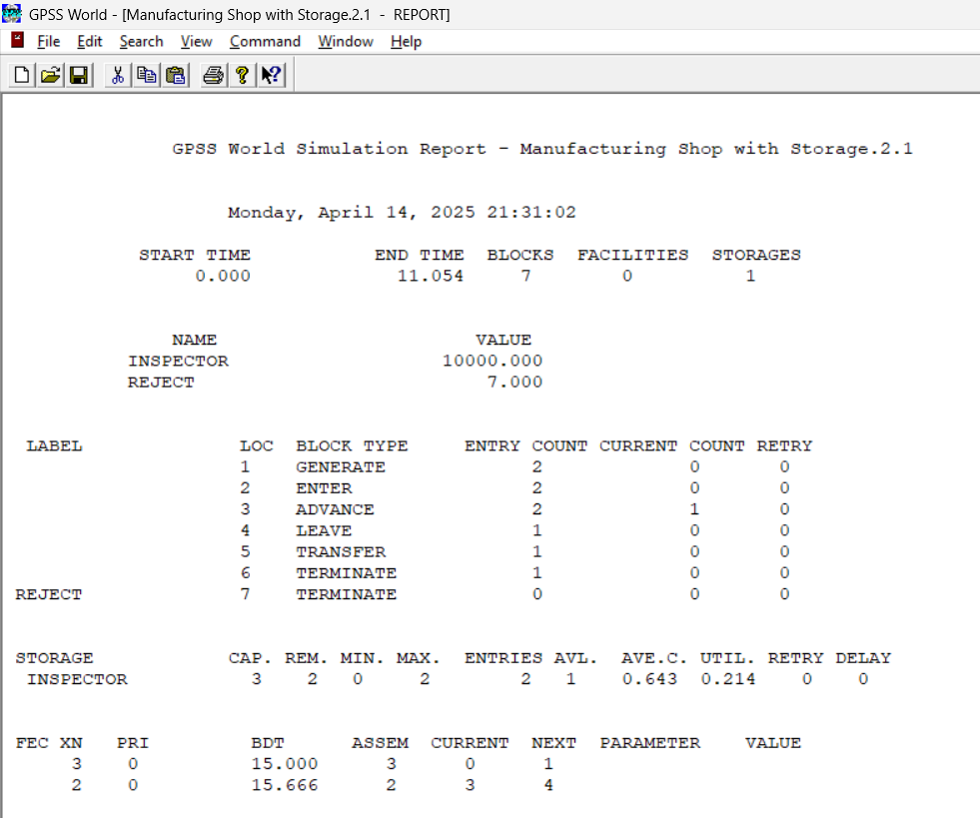

Q.no.2. Fuel Station Simulation: One vehicle arrives every 2 ± 2 minutes. It takes 5 ± 2 minutes to fuel one vehicle. Number of nozzles = 2. Fuel station operates 10 hours a day. Write a GPSS program to simulate operation of the fuel station for the entire day.
Source Code
GENERATE 2,2
QUEUE FUELQ
ENTER NOZZLE,1
DEPART FUELQ
ADVANCE 5,2
LEAVE NOZZLE,1
TERMINATE 1
NOZZLE STORAGE 2
START 600
Output
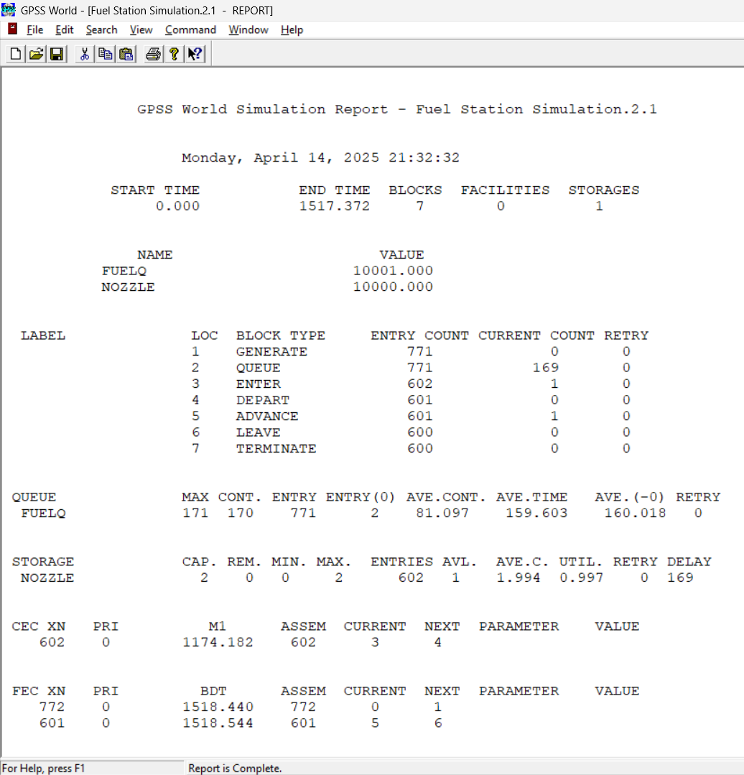

Conclusion
In this lab, we successfully simulated real-life systems using the storage block in GPSS. We demonstrated how a limited number of resources (like inspectors or fuel nozzles) can be managed using the STORAGE, ENTER, and LEAVE blocks. The simulations provided insight into how queues form when the number of entities exceeds available servers. Despite simulator limitations (e.g., no rejection modeling), core resource handling was effectively implemented and observed.

